University Of H-Town

[Student Database]

[Joseph Shoboiki, Esteban Mejia]

* **Abstract:**
* **Mission Statement:**

The purpose of this database system is to create an easy way of accessing one’s courses. Professor’s will be able to manage their lectures and students’ grades and students can keep track of their courses and any information and work the professor’s upload.

* **Mission Objectives:**

To maintain (enter, update, and delete) data on students.

To maintain (enter, update, and delete) data on courses.

To maintain (enter, update, and delete) data on grades.

To maintain (enter, update, and delete) data on workload.

To perform searches on students.

To perform searches on courses.

To perform searches on grades.

To perform searches on workload.

* **Major User Views:**

|  |  |  |  |  |
| --- | --- | --- | --- | --- |
| **Data** | **Access Type** | **Students** | **Staff (Professor)** | **Administrator** |
| Students | Manages  Queries | X  X | X | X |
| Professors | Manages  Queries | X | X | X |
| Courses | Manages  Queries | X | X | X |
| Login | Manages  Queries | X | X | X |
| Course Home Page | Manages  Queries | X | X | X |

* **ER Diagram:**

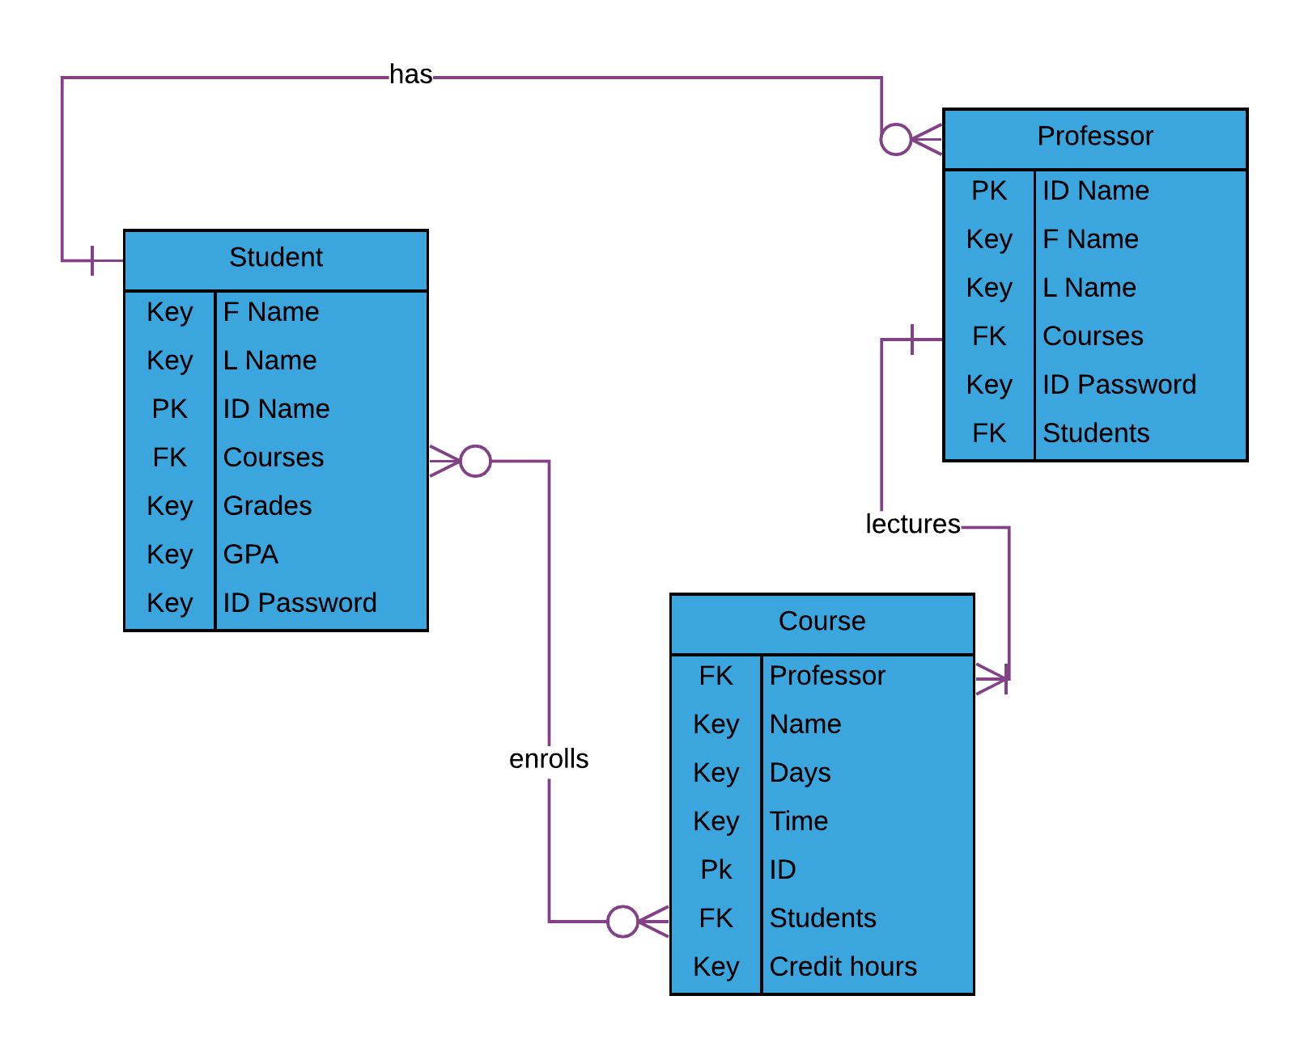

* **Relational Model:**

**Students:**

|  |  |  |  |  |  |  |
| --- | --- | --- | --- | --- | --- | --- |
| ID | F_Name | L_Name | Password | Courses | Grades | GPA |
| Mejiaavel6 | Esteban | Mejia | 08ULgZFt | CS Senior Seminar,  CS Operating System | C, F | 0.8 |
| Richytive13 | Richard | Richy | EbKJGS4q | CS Pro Lang Concepts, CS Operating System, CS Senior Project, CS Database | B,  C,  B,  A | 4 |
| GriffithPieta17 | Guts | Griffith | iiTo9tsh | CS Senior Seminar, CS Pro Lang Concepts, CS Operating Systems,  CS Database | A,  B,  A,  A | 3.7 |
| LanisterDoh5 | Jamie | Lanister | eJ7j99ED | CS Pro Lang Concepts, CS Senior Project | A,  A | 4 |
| ShoboikiBel8 | Joseph | Shoboiki | onnnL8R8 | CS Operating Systems | C | 2 |

**Courses:**

|  |  |  |  |  |  |  |
| --- | --- | --- | --- | --- | --- | --- |
| ID | Name | Professors | Days | Time | Students | Credit hours |
| 4294 | CS Senior Seminar | Speed Wagon | M | 1:00-2:15pm | Esteban Mejia, Guts Griffith | 2 |
| 4303 | CS Pro Lang Concepts | Dio Brando, Orihime Inoue | T, TH | 4:00-5:15pm, 5:00-7:15pm | Richard Richy, Guts Griffith  Jamie Lanister, | 3 |
| 4315 | CS Operating Systems | Jonathon Joestar, Dio Brando, Speed Wagon | TH, S, T | 10:00-12:45pm, 1:00-3:45pm, 4:00-6:45pm | Esteban Mejia, Richard Richy, Guts Griffith, Joseph Shoboiki | 3 |
| 4395 | CS Senior Project | Penelope Cruz | W | 3:30-4:15pm | Richard Richy, Jamie Lanister, | 3 |
| 4313 | CS Database | Orihime Inoue | M, W, F | 10:30-11:45am | Guts Griffith, Richard Richy, | 3 |

**Professor**

|  |  |  |  |  |  |
| --- | --- | --- | --- | --- | --- |
| ID | F_name | L_Name | Courses | Password | Students |
| InoueZule | Orihime | Inoue | CS Pro Lang Concepts, CS Databse | bE4FtepzaSh6 | Richard Richy, Guts Griffith |
| WagonREO | Speed | Wagon | CS Senior Seminar, CS Operating System | kS8TAK9MeEq9 | Esteban Mejia, Guts Griffith |
| Lepenne | Penelope | Cruz | CS Senior Project | D4ReKC5YPKfa | Richard Richy, Bert Osborne  Jamie Lanister |
| JoeJo | Jonathon | Joestar | CS Operating Systems | FLNDa3PeCLRi | Esteban Mejia, Richard Richy, Guts Griffith |
| TheWorld | Dio | Brando | CS Pro Lang Concepts, CS Operating System | SC4rryM0NsT3rs | Bert Osborne, Guts Griffith  Jamie Lanister, Joseph Shoboiki |

* **Use Cases:**

Login:

* Insert Query
  + Actor: Student/Professor/Administrator
  + Steps:
    - User selects the “Username” field
    - User enters their unique ID
    - User then selects “Password” field
    - User enters password
    - User either clicks login or “enter” on keyboard
  + SQL:

INSERT INTO Login (ID, password)

VALUES (“ScottYlid6”, “LB7HQLxp”);

Course info/workload:

* Insert Query
  + Actor: Professor
  + Steps:
    - User selects the “Upload” option
    - A message is displayed to prompt the user to choose a file
    - User selects file
    - File uploaded
* Delete Query
  + Actor: Professor
  + Steps:
    - User selects the “Delete” option.
    - Prompt the user to select which file that they want to delete
    - Message displays asking if user is sure they want to delete file
    - File is deleted
* Update Query
  + Actor: Proffesor
  + Steps:
    - User selects the “Update information” option
    - Prompt the user to choose which file they would like to update
    - User selects file they wish to update
    - User browses for new file
    - User selects new file
    - File is updated

Courses Announcement:

* Insert Query
  + Actor: Professor
  + Steps:
    - User selects the “Add Announcement” option
    - User types announcement
    - User clicks enter or presses enter on keyboard
    - Announcement added

Course Grades:

* Insert Query
  + Actor: Professor
  + Steps:
    - User selects the “Add” option
* Delete Query
  + Actor: Professor
  + Steps:
    - User selects the “Delete” option.
* Update Query
  + Actor: Proffesor
  + Steps:
    - User selects the “Update information” option

Course Student:

* Insert Query
  + Actor: Student
  + Steps:
    - User selects the “Upload” option
    - A message is displayed to prompt the user to choose a file
    - User selects file
    - A 2nd message prompts the user for confirmation
    - File uploaded